January 24, 2018
KHOI LUC
UCLA
104570581
Implementation of forward and inverse kinematic
lab 1

- Introduction:
Kinematics studies the relationship between the independent variables of the joints and the Cartesian positions reached by the robot. There are two types of kinematics:
- Forward kinematics: Find the final position given the length of each link and the angle of each joint
- Inverse kinematic: Given the desired position (x_d), find the joint configuration to get to it.
The focus of this lab is in developing an interactive system for the human-like design pf robots. The key for this lab is to use the kinematics theory for the analysis of multi-joint system.
A robot can be defined as a mechanical system that can be programmed to perform many tasks involving movement under automatic control. The movement of robot can be described in a six-dimensional space that includes translational and rotational coordinates.

In our lab, we imitated a mechanical system consists of a series of rigid links connected by joints. The joints allow relative movement of different types between elements. The most common types of joints in robotic systems are revolute joints, which allow rotary movement between links, and prismatic joints, which allow linear movement between consecutive links
The kinematics of robots focused mainly in determining the kinematics properties of the end link of the robot, the end-effector, with respect to base frame and related to the values of the joint variables. DH parameters are very useful in dealing with two main kinematic analysis problems: the forward kinematics, which consists of computing the position of the end-effector given the values of the joint angles, and inverse kinematics, which consists on determining the necessary joint angles to reach a given end-effector position
Goal: The end effector will apply some force F_1 to pick up an object O_1. Our goal is to imitate human arm as close as possible. We hope our project can contribute to medical field where patients can get robotic arm in place of their biological arm.
Background:
-Operational space: a set of state vectors in which states are represented by state variables of position and orientation.
-Joint space (configuration space): a set of state vectors in which states are represented by joint variables
Conversion from joint space to operational space is called forward kinematics, and conversion from operational space to joint space is called inverse kinematics
- Method:
- DH Parameters:
For this lab, I followed “Modifed” DH convention.
Task:
There are 3 stages in our arm movement:
-(0,0,0,0) , (0, pi/4,0,0) and (0,pi/2,0,0)
The length of the arm will L2 + L4 which L2 is the length from shoulder to elbow, L4 is the length from elbow to the wrist (end – effector)
First, I had to find the Denavit-Hartenberg parameters for the linkage system.

Parameter | i=1 | i=2 | i=3 | i=4 | i=5
d | 0 | 0 | L2 = 30 | 0 | 0
$$θ$$ | $$θ_{1}$$ | $$θ_{2}$$ | $$θ_{3}$$ | $$θ_{4}$$ | $$θ_{5}$$
a | 0 | 0 | 0 | L4 = 20 | 0
$$α$$ | 0 | 90 | 90 | 90 | 0

$$T_{i+1}^{i}=\left[\begin{matrix}cosθ_{i} & -sinθ_{i}cosα_{i} & sinθ_{i}sinα_{i} & a_{i}cosθ_{i} \\ sinθ_{i} & cosθ_{i}cosα_{i} & -cosθ_{i}sinα_{i} & a_{i}sinθ_{i} \\ 0 & sinα_{i} & cosα_{i} & d_{i} \\ 0 & 0 & 0 & 1\end{matrix}\right]$$

By doing so I got the following:

$$T_{5}^{0}=T_{1}^{0}*T_{2}^{1}*T_{3}^{2}*T_{4}^{3}*T_{5}^{4}$$

Next, the kinematic equation can be solved by applying:
$p_{5}^{0}=T_{5}^{0}* p_{5}^{5}$

Position of end-effector in frame 0 is the transformation of end-effector in frame 0 multiplied with the position of end-effector in its own frame

Inverse Kinematics:
Assuming the end-effector position is fixed relative to the frame n. Then, the end-effector position vector x in world frame is a function which purely depends on joint space variables.

$$x=f\left(q\right)$$At $q_{0},$
$$x_{0}=f(q_{0})$$
We have
$$δx=f\left(q+δq\right)-f(q)$$

As $δ$ goes to infinitely small, we have:
$$dx=f^{'}\left(q\right)dq \\ = J_{v}\left(q\right)dq$$
So,
$$dq= J_{v}^{-1}\left(q\right)dx$$

Inverse Kinematic Algorithm:
- Given an operational space vector $x_{0}$ and corresponding joint space vector $q_{0}$ as initial point
- Pick a step size $δx$ towards goal
- Find $δq=J^{-1}\left(q_{i}\right) δx$and calculate $q_{i+1}=q_{i}+δ_{q}$
- Calculate corresponding operational space vector $x_{i+1}$using forward kinematics
- Check if $x_{i+1}$ is close enough to the destination point. If yes, we have found q. If not go back to step 2 with new x and q
- Analysis:
Note: I shared the same data and code with my partner Cuong Hoang. I confirm that those are the only thing we shared
- Forward kinematic:
Test 1: turn joint 2 0, 45, and 90 degrees:
$$A=FK \left(0, 0,0,0\right) \\ B=FK \left(0, 0.785398,0,0\right) \\ C=FK \left(0, 1.5708,0,0\right)$$
Here is the result of the graph
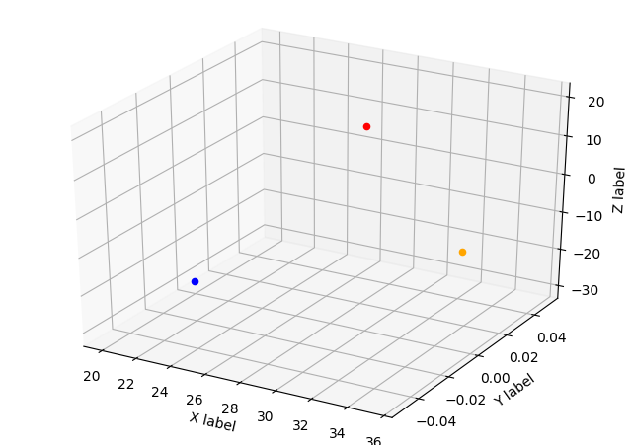
Red color is A, B is green, and C is blue
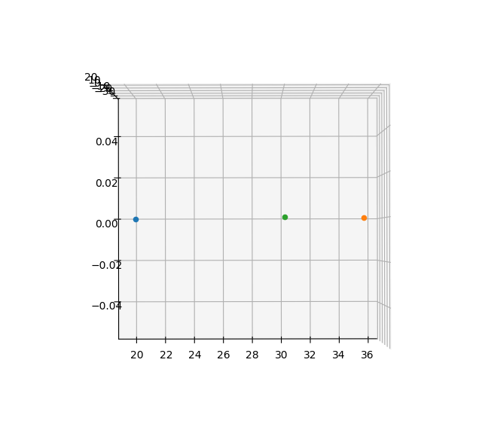
Figure 1: y-coordinate does not change
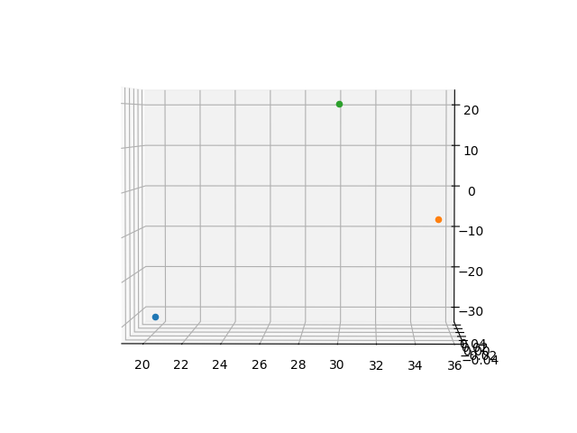
Figure 2 x and z coordinates changed

For inverse kinematic, I used the output of FK to be the input of IK, here is the result:
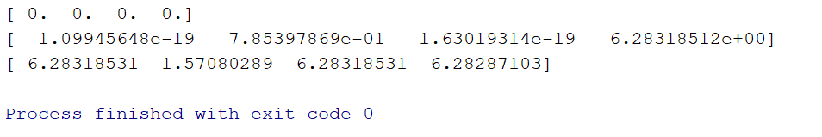
6.28 is equivalent to 0 radian, which meant our FK and IK are correct
Trajectory:
The distance of the joint resulted from configuration space will be longer compared to the linear motion straight line operational space. This is because the linkage moves in the arch trajectory not a perfect straight line.
- Github’s Repository:

- Reference:
1.Siciliano, Bruno. 2010. “Robotics: Modelling, Planning and Control”. Springer Publisher. 2010
2. Professor Mehta, Ankur ‘s Lecture Notes. Transcribed by Tianrui Zhang in Fall 2016

‘’’
For this lab, I partner with Cuong Hoang. His UID: 004847900
My contribution: jacobian.py, forward_kinamatic.py (50% of the work)
I spent about 15 hours total, mostly on debugging the code and re-did the DH convention.
‘’’

